**Project 3 Write out**

Tianrun Gu

Frames = 8:

**gcc.trace:**

OPT:

* Total page faults: 13328
* Total writes to disk: 4380

FIFO:

* Total page faults: 29011
* Total writes to disk: 11519

Aging:

In my test, based on the multiple of 10, I found “40” is the best choice for refreshing rate. Following are statics:

R = 30:

* Total page faults: 22487
* Total writes to disk: 6932

R = 40:

* Total page faults: 22312
* Total writes to disk: 6732

R = 50:

* Total page faults: 22484
* Total writes to disk: 6769

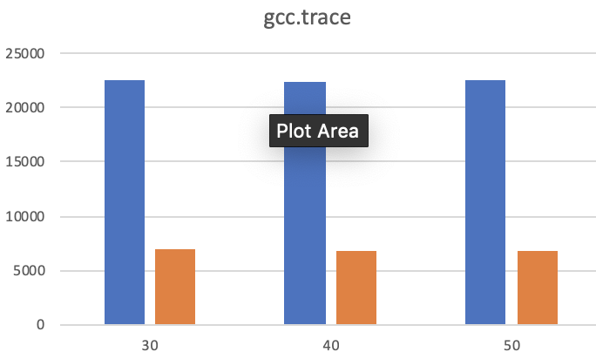

Summary: for gcc.trace, when the frames = 8, the best algorithm should be “OPT” because it has least page faults and disk writes. “OPT” in this case could promise the best CPU and I/O performance. But in the real world, we should use “aging” because it provides better performance on both fields than “FIFO” does.

**gzip.trace**:

OPT:

* Total page faults: 44918
* Total writes to disk: 39844

FIFO:

* Total page faults: 39874
* Total writes to disk: 39844

Aging:

During my test, based on the multiple of 10, I found the best refreshing period should be “20”. Following are statics:

R = 10:

* Total page faults: 39906
* Total writes to disk: 39863

R = 20:

* Total page faults: 39904
* Total writes to disk: 39860

R = 30:

* Total page faults: 39898
* Total writes to disk: 39859

R = 40:

* Total page faults: 39901
* Total writes to disk: 39861

Summary: for gzip.trace, when the frames = 8, the best algorithm should be “FIFO” because all three algorithms have similar number of page faults and number of disk writes. But “FIFO” in this case has relative advantage for both statics. Another reason is that “FIFO” is the easiest one to implement. So “FIFO” is the best for this case.

**swim.trace:**

OPT:

* Total page faults: 4417
* Total writes to disk: 2182

FIFO:

* Total page faults: 13893
* Total writes to disk: 8499

Aging:

During my test, based on the multiple of 5, I found the best refreshing period should be “10” because it has least page faults which could save a lot context switch. Following are statics:

R = 5:

* Total page faults: 23078
* Total writes to disk: 3664

R = 10:

* Total page faults: 8600
* Total writes to disk: 4280

R = 20:

* Total page faults: 9315
* Total writes to disk: 4677

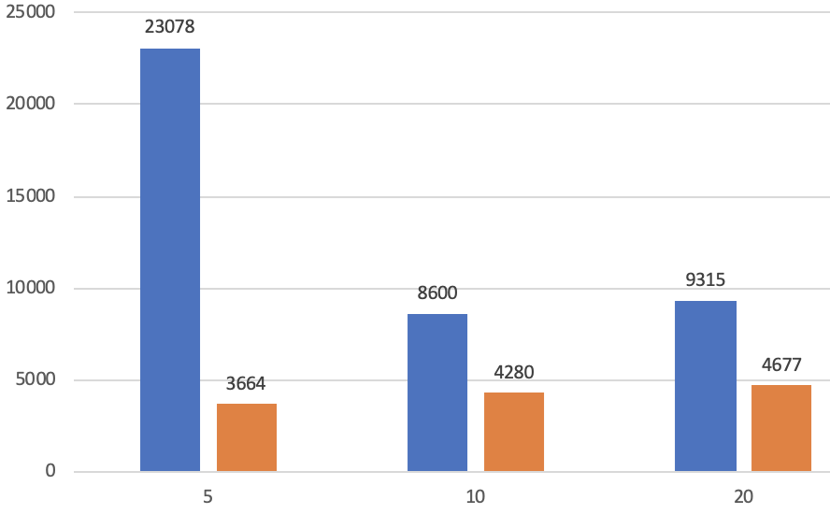

Summary: for swim.trace, I found the “OPT” totally wins this one. “OPT” has advantage in both “page faults” and “disk writes”, which could provide the best CPU and I/O performance. But in the real world, we should use “aging” because it does better on both fields than “FIFO” does.

************************************************************************

*****************************************************************

Frames = 16:

**gcc.trace:**

OPT:

* Total page faults: 3020
* Total writes to disk: 1019

FIFO:

* Total page faults: 8568
* Total writes to disk: 3542

Aging:

In my test, based on the multiple of 50 refresh periods, I found “250” is the best choice for refreshing rate. Following are statics:

R = 200:

* Total page faults: 5837
* Total writes to disk: 1865

R = 250:

* Total page faults: 5835
* Total writes to disk: 1814

R = 300:

* Total page faults: 5864
* Total writes to disk: 1756

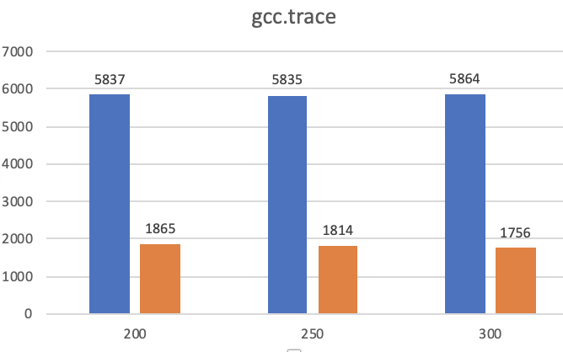

Summary: for gcc.trace, I found the “OPT” totally wins this one. “OPT” has advantage in both “page faults” and “disk writes”, which could provide the best CPU and I/O performance. But in the real world, we should use “aging” because it defeats “FIFO” on both aspects.

**gzip.trace**:

OPT:

* Total page faults: 39856
* Total writes to disk: 39825

FIFO:

* Total page faults: 42384
* Total writes to disk: 39856

Aging:

R = 500:

* Total page faults: 39888
* Total writes to disk: 39849

R = 500:

* Total page faults: 39927
* Total writes to disk: 39854

R = 1000:

* Total page faults: 40107
* Total writes to disk: 39919

**swim.trace:**

OPT:

* Total page faults: 358
* Total writes to disk: 149

FIFO:

* Total page faults: 844
* Total writes to disk: 470

Aging:

R = 250:

* Total page faults: 560
* Total writes to disk: 259

R = 500:

* Total page faults: 562
* Total writes to disk: 256

R = 1000:

* Total page faults: 672
* Total writes to disk: 288

*****************************************************************

Frames = 32:

**gcc.trace:**

OPT:

* Total page faults: 491
* Total writes to disk: 215

FIFO:

* Total page faults: 1375
* Total writes to disk: 660

In my test, based on the multiple of 50 refresh periods, I found “900” is the best choice for refreshing rate. Following are statics:

Frames = 32:

R = 850:

* Total page faults: 762
* Total writes to disk: 354

R = 900:

* Total page faults: 758
* Total writes to disk: 352

R = 950:

* Total page faults: 768
* Total writes to disk: 360

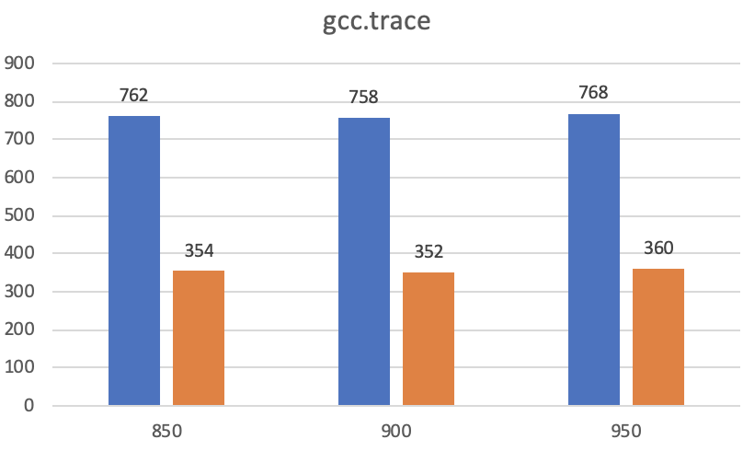

**gzip.trace**:

OPT:

* Total page faults: 39856
* Total writes to disk: 39809

FIFO:

* Total page faults: 41120
* Total writes to disk: 39825

Aging:

R = 20:

* Total page faults: 39875
* Total writes to disk: 39822

R = 30:

* Total page faults: 39874
* Total writes to disk: 39822

R = 40:

* Total page faults: 39874
* Total writes to disk: 39822

**swim.trace:**

OPT:

* Total page faults: 144
* Total writes to disk: 60

FIFO:

* Total page faults: 326
* Total writes to disk: 158

Aging:

R= 2000:

* Total page faults: 209
* Total writes to disk: 82

R = 3000:

* Total page faults: 203
* Total writes to disk: 77

R = 4000:

* Total page faults: 214
* Total writes to disk: 82

*****************************************************************

Frames = 64:

**gcc.trace:**

OPT:

* Total page faults: 318
* Total writes to disk: 105

FIFO:

* Total page faults: 551
* Total writes to disk: 258

Aging:

In my test, based on the multiple of 10000 refresh periods, I found “20000” is the best choice for refreshing rate. Following are statics:

R = 10000:

* Total page faults: 433
* Total writes to disk: 178

R = 20000:

* Total page faults: 419
* Total writes to disk: 170

R = 30000:

* Total page faults: 536
* Total writes to disk: 172

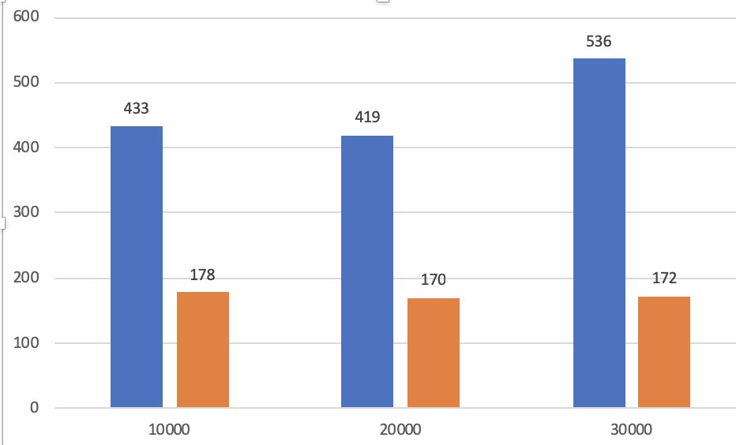

**gzip.trace**:

OPT:

* Total page faults: 39856
* Total writes to disk: 39777

FIFO:

* Total page faults: 40496
* Total writes to disk: 39793

Aging:

R = 10:

* Total page faults: 39877
* Total writes to disk: 39791

R = 75:

* Total memory accesses: 39873
* Total page faults: 39789

R = 100:

* Total page faults: 39873
* Total writes to disk: 39789

**swim.trace:**

OPT:

* Total page faults: 135
* Total writes to disk: 26

FIFO:

* Total page faults: 177
* Total writes to disk: 69

Aging:

R = 10000:

* Total page faults: 145
* Total writes to disk: 47

R = 20000:

* Total page faults: 141
* Total writes to disk: 46

R = 30000:

* Total page faults: 142
* Total writes to disk: 45

*****************************************************************